

SIMATS ENGINEERING

Saveetha Institute of Medical and Technical Sciences
Chennai- 602105

Student Name: A.P.GAUTHAM SINGH Reg. No: 192412007
Course Code: CSA1711 Slot: C
Course Name: ARTIFICIAL INTELLIGENCE
Course Faculty: Dr. Krishna Kumar Kathiresan
Project Title: House price predictionAn AI-based approach to estimating residential property value from structured housing data

Module Photographs:
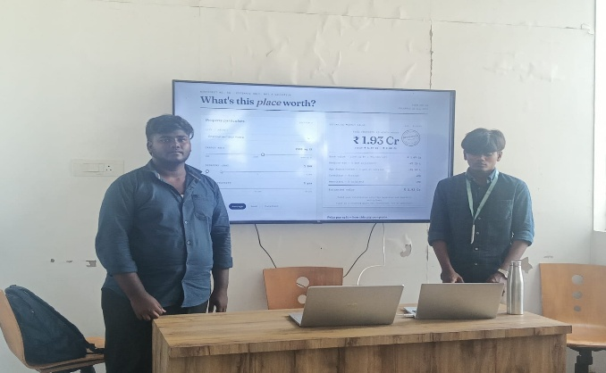
Project Description:
This project is a desktop application built in Python that predicts residential property prices in Bangalore using a machine learning model trained on the "Bengaluru House Price Data" dataset from Kaggle. The raw dataset, containing 13,320 property listings, was cleaned and preprocessed into 7,201 usable records by handling missing values, removing inconsistent entries, and encoding categorical features such as locality and area type. A Linear Regression model from scikit-learn was then trained on this cleaned data using features including total area (in square feet), number of bathrooms, BHK (bedroom count), number of balconies, locality (29 distinct areas), and area type (Super built-up, Built-up, Carpet, or Plot Area), achieving a holdout R² score of 0.743 and a Mean Absolute Error of ₹21.43 Lakh on unseen data. Rather than requiring the model to be retrained every time, the learned coefficients are embedded directly into the application, allowing it to launch instantly using only Python's built-in Tkinter library, with no external dependencies needed for everyday use. The interface, styled as a clean worksheet-like layout, allows users to interactively select a locality and adjust sliders for area, BHK, bathrooms, and balconies, instantly generating a predicted market value along with a transparent breakdown showing exactly how each feature (area, locality premium, BHK adjustment, etc.) contributes to the final price. The app also includes an optional "Retrain from CSV" feature for users who wish to rerun the full training pipeline using pandas and scikit-learn on updated data, along with an "About this model" section documenting the dataset source, model type, performance metrics, and known limitations such as multicollinearity effects between BHK, balconies, and square footage. Overall, this project demonstrates a complete end-to-end machine learning workflow — from raw data cleaning and model training to deployment as an interactive, user-friendly desktop tool — making it a practical example of applying regression-based predictive analytics to real-world real estate valuation.

Student Signature Guide Signature

